Week 3&4

Gnomeo and Juliet MAVO/HAVO/VWO
You may have heard or read about the famous play ‘Romeo and Juliet’. The writer of this famous play can be described as a ‘Homo Universalis’. He was described as a true linguist; responsible for many words in the English language.
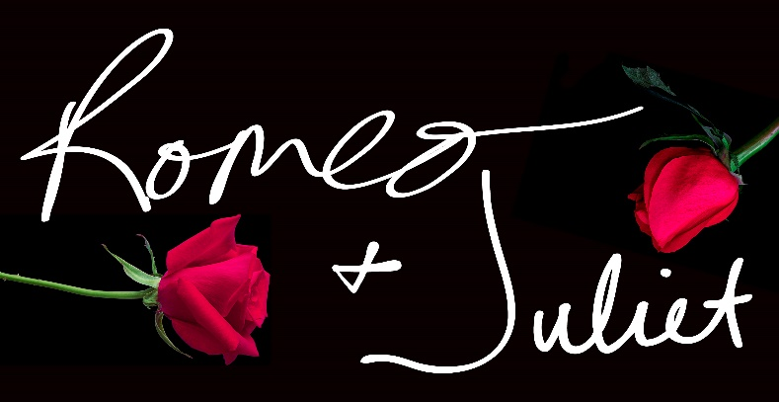
Romeo and Juliet isn’t his only signature play: Hamlet, Macbeth, King Lear, A midsummer’s night’s dream and Othello are just a few of the plays that he has written. He was a poet, a writer for plays and considered one of the greatest writers ever lived. In short, the story is about the love between two young people from noble families that are enemies. In class, we are going to have a look at the short movie ‘Gnomeo and Juliet’.

The original story
A. Before we start, answer the questions below. Use your knowledge and the internet to find your answers.
- The original story Romeo and Juliet is written by?
________________________________________________________________________________________________________________________________________________________
- When and where did the writer live?
________________________________________________________________________________________________________________________________________________________
- In which famous theatre were his plays performed?
________________________________________________________________________________________________________________________________________________________
- Find two other plays by the same writer:
________________________________________________________________________________________________________________________________________________________
- What are the surnames of the families in the story? Romeo: ................................. Juliet: ...................................

HAVO / VWO
- Give 4 more characters that play an important role.
________________________________________________________________________________________________________________________________________________________________________________________________________________________________________________________________________________________________________________
VWO
- The play starts with a prologue. What is a prologue?
________________________________________________________________________________________________________________________________________________________
- Finish the sentence form the Romeo and Juliet prologue: ‘Two households…’
____________________________________________________________________________

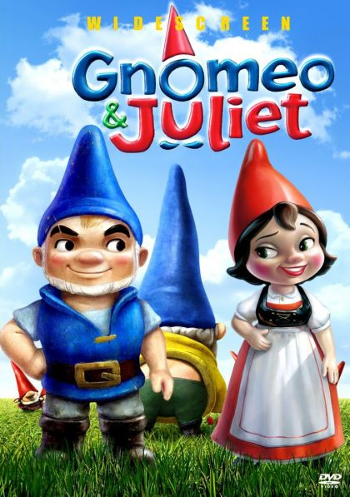
Gnomeo and Juliet
B. The film you are about to watch in class is divided into 5 parts. During the film, try to fill in the missing words in the grid (tabel) below. At the same time, try to answer the questions. You have to scroll between the two exercises in order to find the answers. Als je dit erg lasting vindt kun je eerst de ontbrekende woorden in het schema invullen. Probeer vervolgens antwoord te geven op de onderstaande vragen.
Missing words form the video:
Part 1 | Part 2 | Part 3 | Part 4 | Part 5
1. | 1. | 1. | 1. | 1.
2. | 2. | 2. | 2. | 2.
3. | 3. | 3. | 3. | 3.
4. | 4. | 4. | 4. | 4.
5. | 5. | 5. | 5. | 5.
6. | 6. | 6. | 6. | 6.
7. | 7. | 7. | 7. | 7.
8. | 8. | 8. | 8. | 8.
9. | 9. | 9. | 9. | 9.
10. | 10. | 10. | 10. | 10.
11. | 11. | 11. |  | 11.
12. | 12. | 12. |  | 12.
13. | 13. | 13. |  | 13.
14. | 14. | 14. |  | 14.
15. | 15. | 15. |  | 15.
Part 1
- What are the names of the two families in the story?
________________________________________________________________________________________________________________________________________________________
- What is their main occupation?
________________________________________________________________________________________________________________________________________________________
- The word ‘delicate’ is mentioned a couple of times. What do you think it means?
________________________________________________________________________________________________________________________________________________________
- What is the name of the person who wins the race? Was it a fair race?
________________________________________________________________________________________________________________________________________________________
- What is Julia’s plan? What is she wearing?
________________________________________________________________________________________________________________________________________________________
Part 2

- Who is living in the greenhouse?
________________________________________________________________________________________________________________________________________________________
- Why are they so scared of each other when they end up in the water?
________________________________________________________________________________________________________________________________________________________
- What is the initial reaction of Nanette the Frog?
________________________________________________________________________________________________________________________________________________________
- At first, they are going to meet each other the next day at ‘noon’. What time is noon?
________________________________________________________________________________________________________________________________________________________
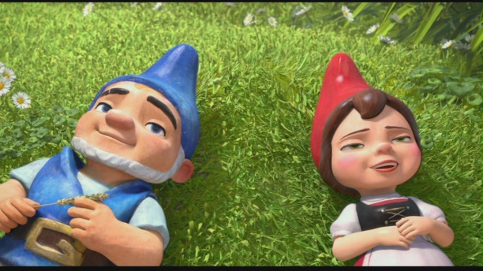
Part 3
- What is Tybalts plan?
_____________________________________
_____________________________________
_____________________________________
_____________________________________
_____________________________________
- Why does Julia’s dad bring Paris into the picture?
________________________________________________________________________________________________________________________________________________________
- Where does Featherstone come from?
________________________________________________________________________________________________________________________________________________________
Part 4
- Why does Gnomeo want to cancel the mission? What happened?
________________________________________________________________________________________________________________________________________________________
- What do you think the phrase ‘it isn’t as bad as all that’ means?
________________________________________________________________________________________________________________________________________________________
- What has happened to Featherstone?
________________________________________________________________________________________________________________________________________________________
- What has broken?
________________________________________________________________________________________________________________________________________________________
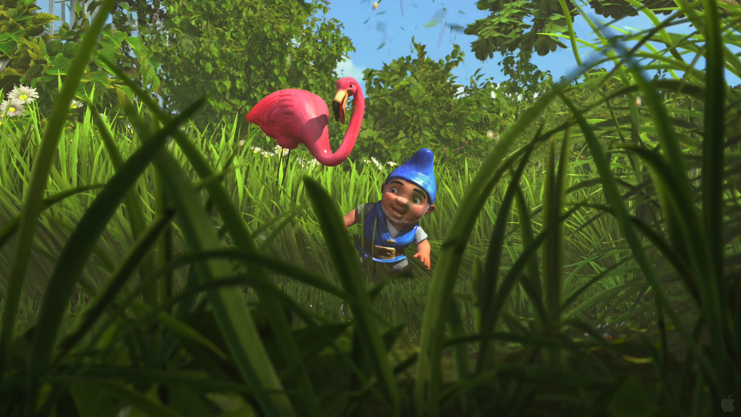
Part 5
- What is the little mushroom (Shroom) trying to tell everybody?
________________________________________________________________________________________________________________________________________________________
- In the film, the writer of the play states that there are some remarkable similarities between the two stories. Can you name two?
_______________________________________________________________________________________________________________________________________________________

C. Answer the questions below.
1. How does the film end?
________________________________________________________________________________________________________________________________________________________________________________________________________________________________________________________________________________________________________________________________________
2. And how does the original story end?
________________________________________________________________________________________________________________________________________________________________________________________________________________________________________________________________________________________________________________________________________
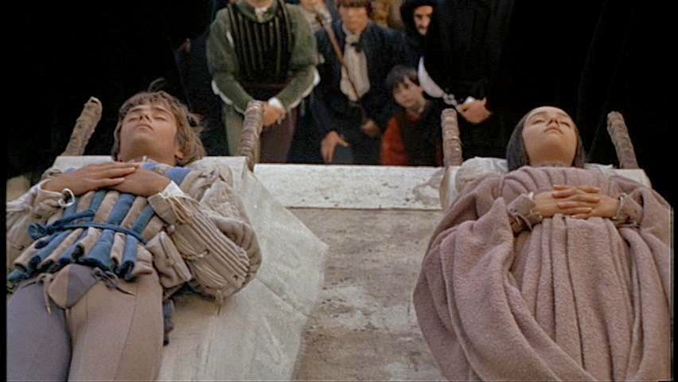
3. It is true that there are some similarities between this story and the real Romeo and Juliet, but some things are different or have been changed a bit. Give two similarities and two things that are different.
________________________________________________________________________________________________________________________________________________________________________________________________________________________________________________________________________________________________________________________________________________________________________________________________________________________________________________________________________________________________________________________________________________________________________________________________________________________________________________________________________________
(If you need to look up the Romeo and Juliet story on Wikipedia, you’re allowed to)

HAVO/VWO
4. Which ending do you prefer? Why? Support your answer using at least 5 lines.
________________________________________________________________________________________________________________________________________________________________________________________________________________________________________________________________________________________________________________________________________________________________________________________________________________________________________________________________________________________________________________________________________________________________________________________________________________________________________________________________________________
(MAVO/HAVO) VWO
5. In a few lines rewrite the story of Romeo and Juliet, but this time change the setting to modern day. Your characters cannot be fictional (they have to exist), but they can be movie- or film stars of course. Make sure that your ending is (a bit) different from the original play. Enjoy!
(Again, if you need to look up some information on Wikipedia, you’re allowed to)
________________________________________________________________________________________________________________________________________________________________________________________________________________________________________________________________________________________________________________________________________________________________________________________________________________________________________________________________________________________________________________________________________________________________________________________________________________________________________________________________________________________________________________________________________________________________________________________________________________________________________________________________________________________________________________________________________________________________________________________________________________________________________________________________________________________________________________________________________________________________________________________________________________________________________________________________________________________________________________________________________________________________________________________________________________________________________________________________________________________________________________________________________________________________________________________________________________________________________________________________________________________________________________________________________________________________________________________________________________________________________________________________________________________________________________________________________________________________________________________________________________________________________________

